**DAILY ONLINE ACTIVITIES SUMMARY**

|  |  |  |  |  |  |  |  |  |
| --- | --- | --- | --- | --- | --- | --- | --- | --- |
| **Date:** | **26/05/2020** | | | | | **Name:** | **Prashant Rama Bhat Kodlekere** | |
| **Sem & Sec** | **4th sem (B sec)** | | | | | **USN:** | **4AL18CS060** | |
| **Online Test Summary** | | | | | | | | |
| **Subject** | | **DESIEGN AND ANALYSIS OF ALGORITHMS** | | | | | | |
| **Max. Marks** | | **30** | | **Score** | | | **27** | |
| **Certification Course Summary** | | | | | | | | |
| **Course** | **Introduction to cyber security(4th and 5th session)** | | | | | | | |
| **Certificate Provider** | | | **Udemy** | | **Duration** | | | 1.5 hrs |
| **Coding Challenges** | | | | | | | | |
| **Problem Statement:** [Write a program in C to print all permutations of a given string using pointers.](https://github.com/orgs/alvas-education-foundation/teams/2nd-year/discussions/81)  Top of Form  Bottom of Form | | | | | | | | |
| **Status:Completed** | | | | | | | | |
| **Uploaded the report in Github** | | | | | **YES** | | | |
| **If yes Repository name** | | | | | **https://github.com/prashantkodlekere/codingactivity** | | | |
| **Uploaded the report in slack** | | | | | **YES** | | | |

Online Test Details:

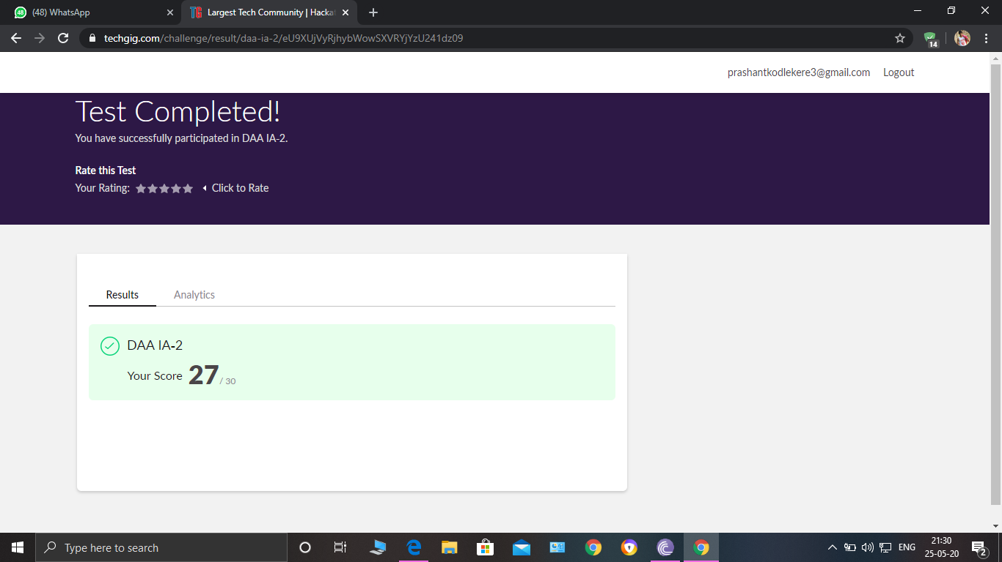

DESIEGN AND ANALYSIS OF ALGORITHMS Internals was conducted. A total of 30 questions were Multiple Choice Questions.

The above snapshot is the result sheet which was mailed to us by the Techgig team.

Certification Course Details:

Course name : introduction to cyber security(4th and 5th session)

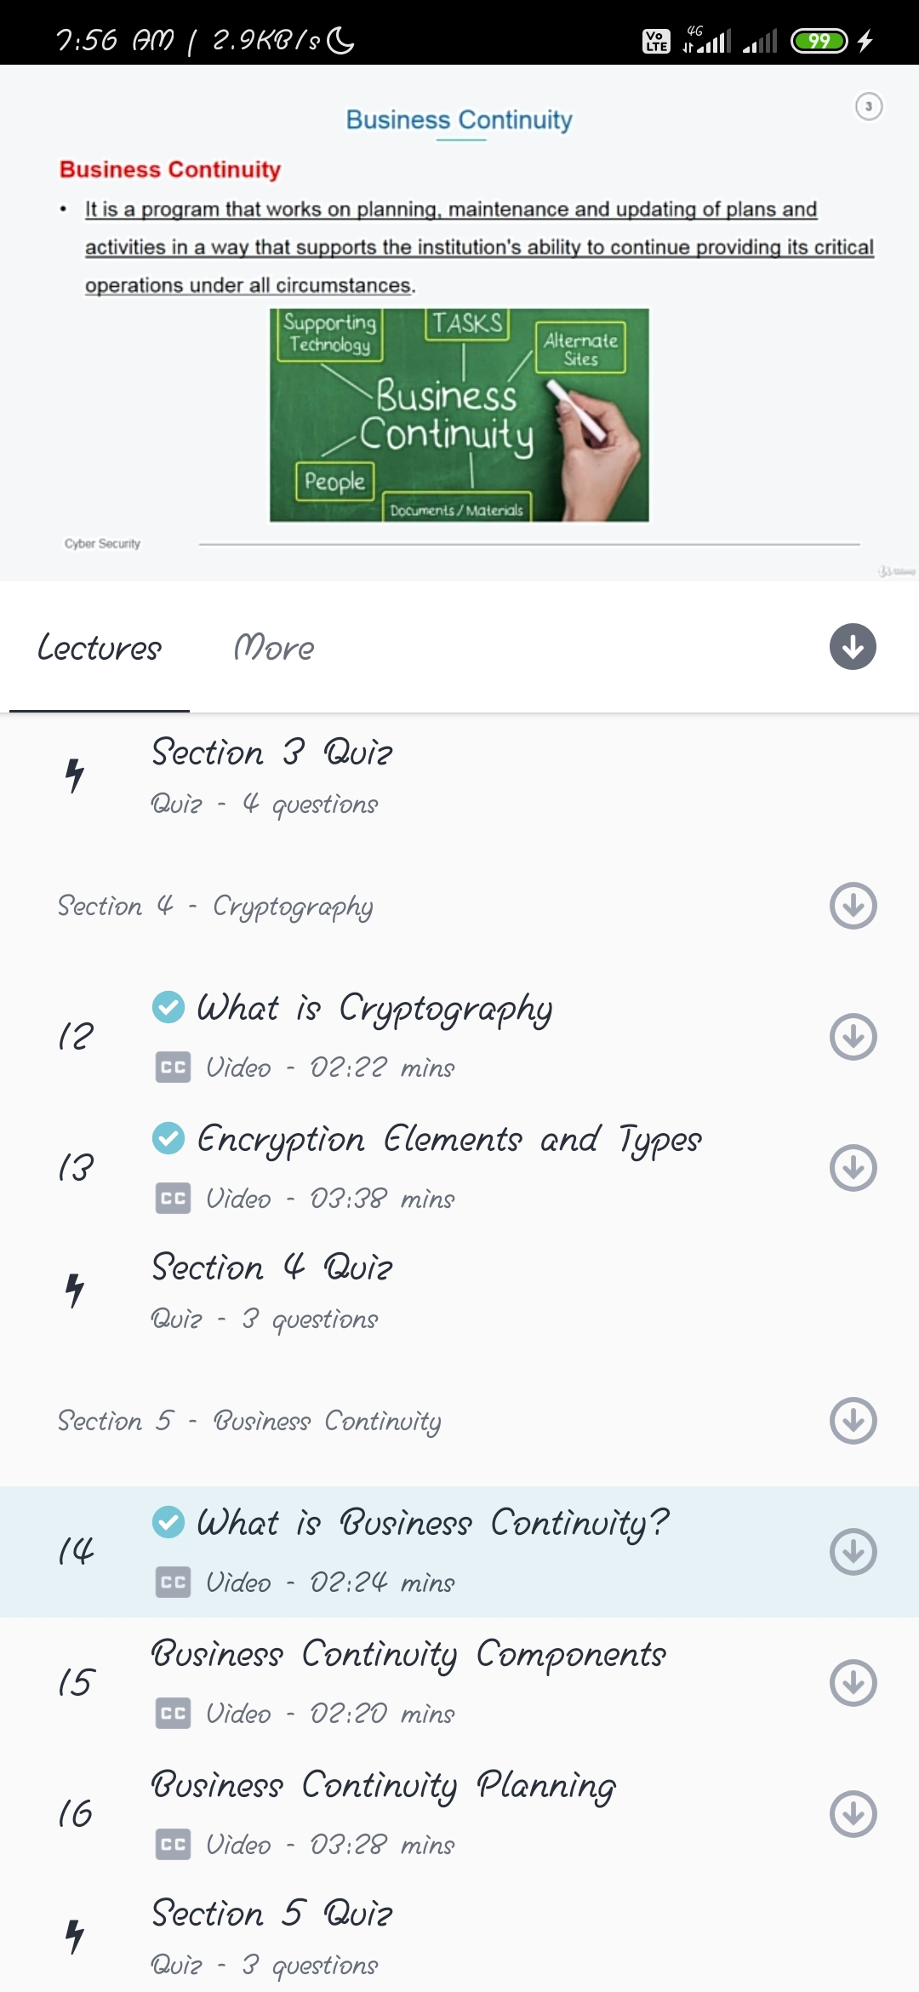

In session 4,I have learnt what is cryptography and encryption element and types.

In session 5,I have learnt about business continuity and its components and planning.

Coding Challenges Details:

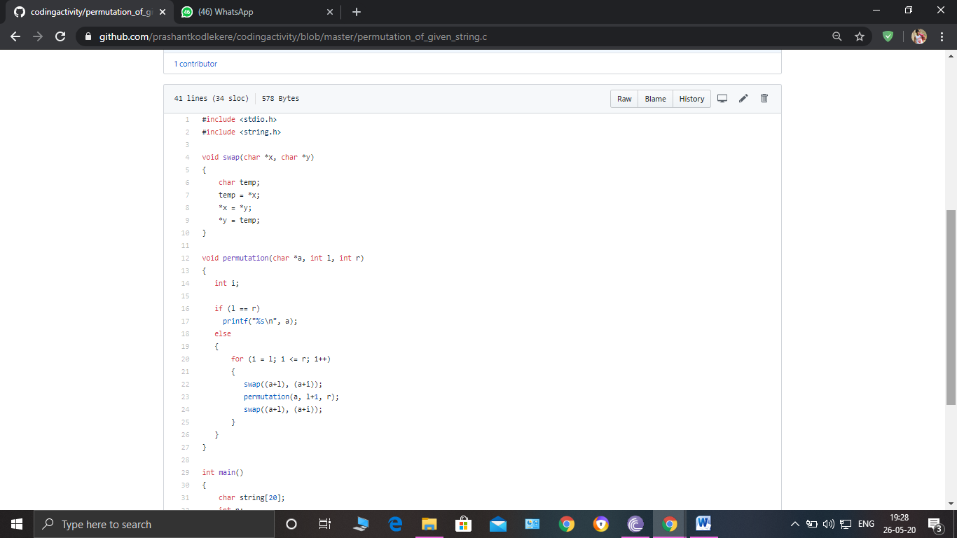

**The question I took to code is:**

Write a program in C to print all permutations of a given string using pointers.

Code: The above snapshot is the code which I have uploaded in my Github repository.